Any questions: Mosheer <https://www.facebook.com/mosheer.abuantar>

To upload or find resources, please go to this link:

<https://drive.google.com/drive/folders/0B7KHpVBDaDi5VW9wYjR3dm9XU3M?usp=sharing>

**Please keep the structure as it is. We need to have organized files to ease the search for any resource**. To do so, please follow these conventions:

Each course has a folder, so please upload what you have in each COURSE folder. Most important is the exams.

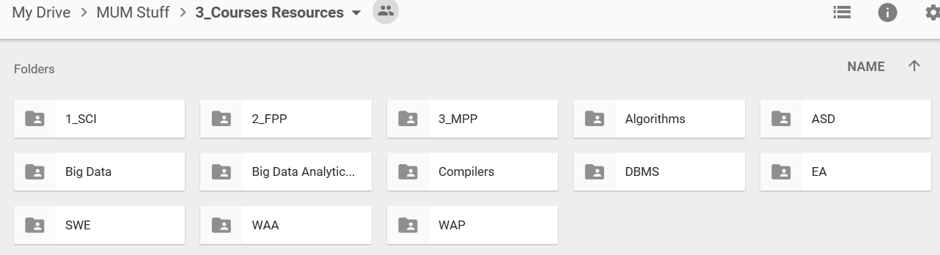

Zip the material you have in this name format:   
Year_MonthShortName_ProfessorName. For example: 2016_Jan_Salek

If the material is DE, then add the prefix DE to the name. For example: DE_2016_Jan_Salek

If you want to upload Labs/assignments/Exams …etc, it is better to put them in one zip file as above name. If you want to upload the exams only, then upload them to the corresponding sub folder (Midterms/finals) as shown in this image

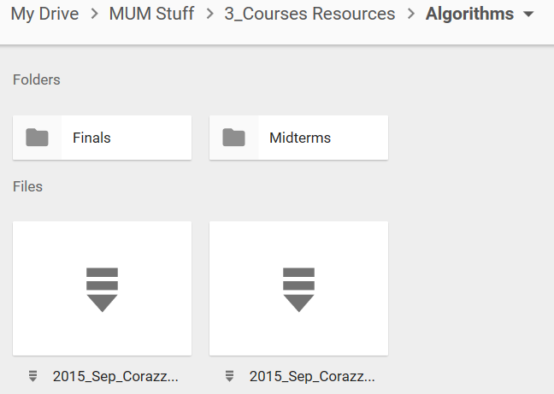

Exams can be found: in the sub folders (i.e. Midterms/Finals), or inside the zip files (if they have)